AWS S3 (Simple Storage Service) (it is chargeable)

Flat file storage

S3 bucket name is unique in region

By default, S3 bucket is private

By default, S3 version is disabled

S3 is global service

S3 bucket is regional service

S3 is unlimited storage

Mainly S3 is used to store artifacts nothing but scripts

Process the data, if you wanted to process the bulk data into data base, the data should be stored into S3 bucket only

By using S3 replication, we can save the same file in different regions

S3 Cross region replication (here s3 version enable is mandatory)

By using this option if we create a bucket into one region, the same bucket is created into other region but if we delete a bucket in any region, the other region bucket will not be deleted.

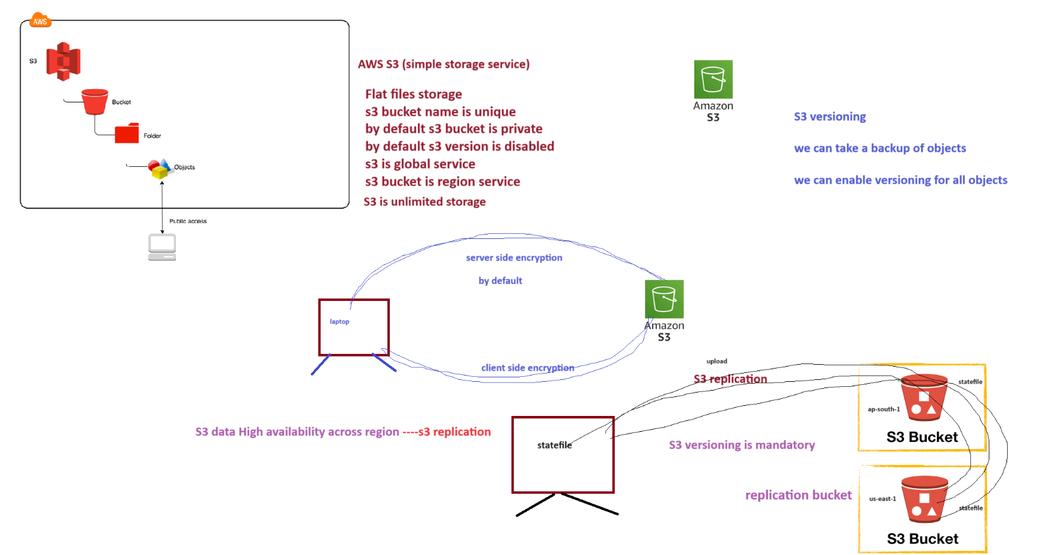

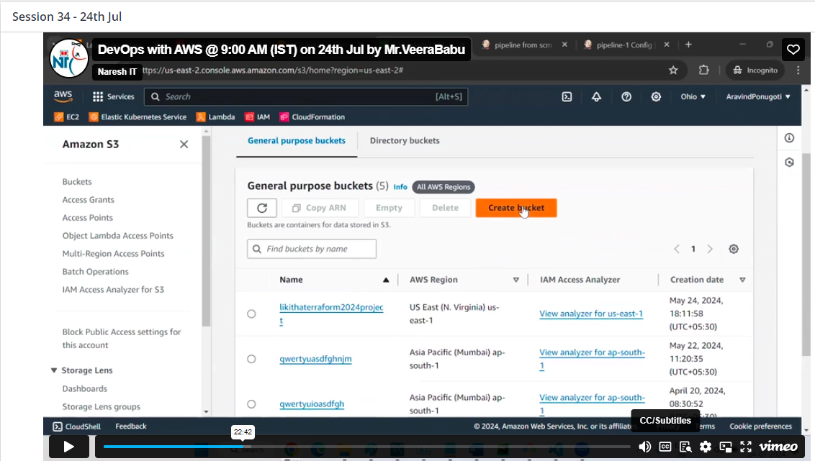any name but name should be unique for s3 bucket

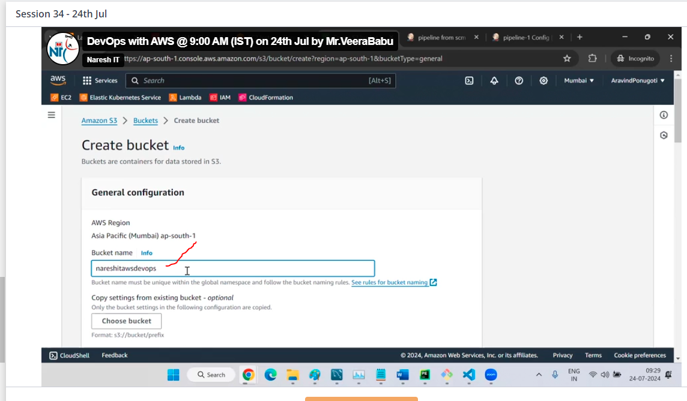

Un check block public

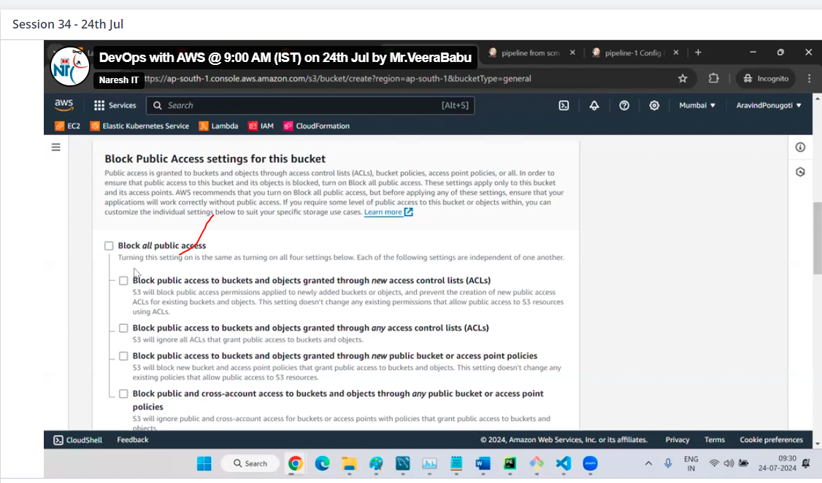

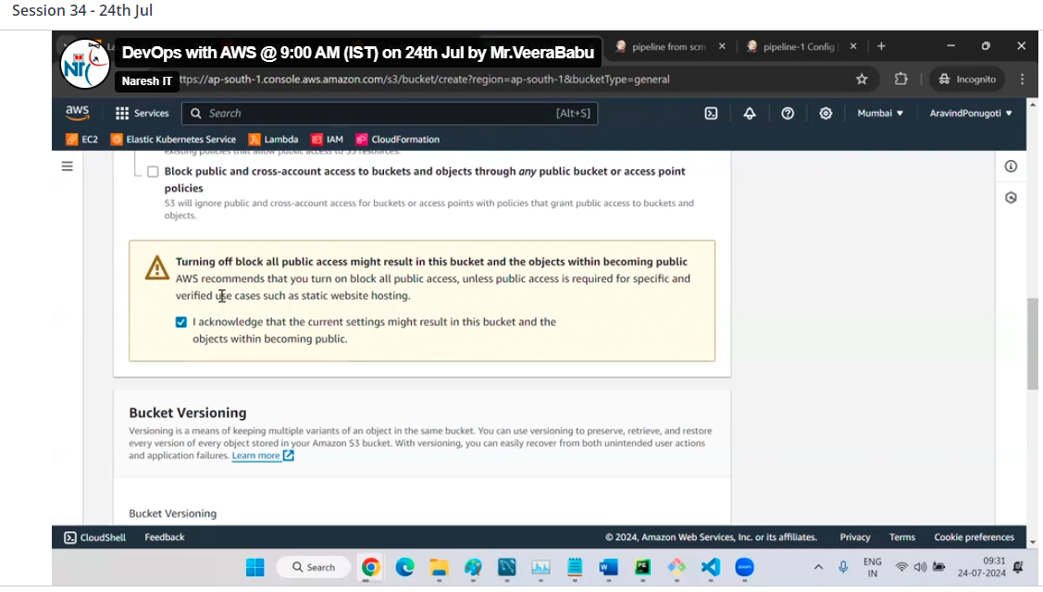

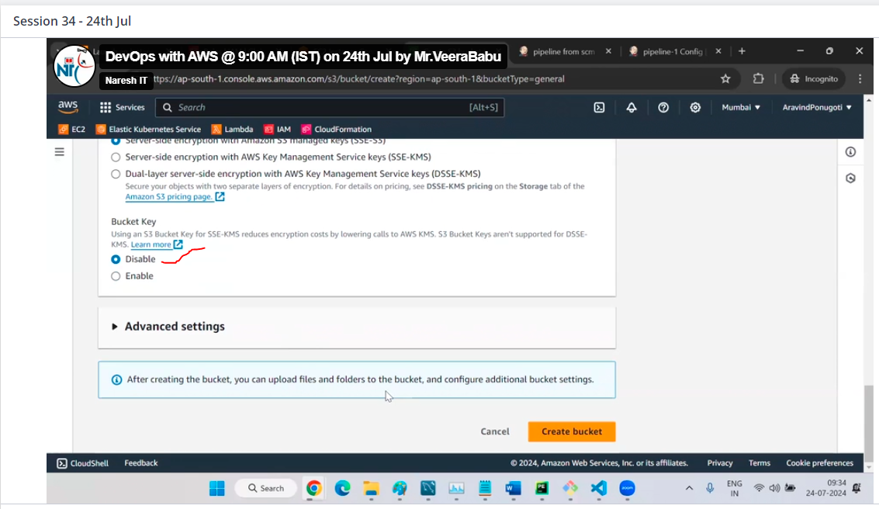

Then click on create a bucket

Now s3 bucket is done, then creating a folder in S3

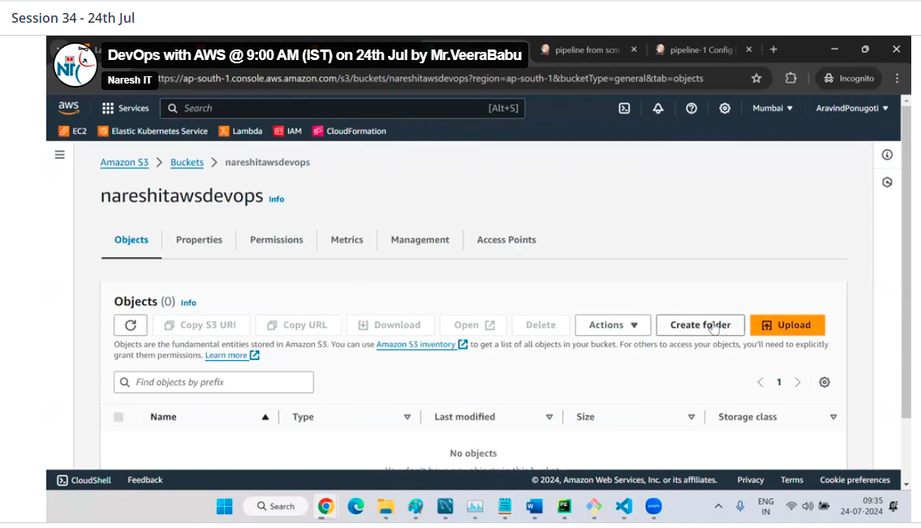

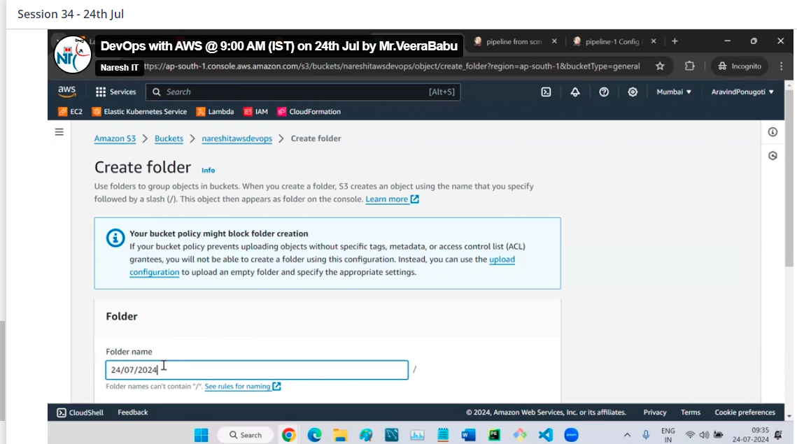

Click on create

Now upload a file in folder

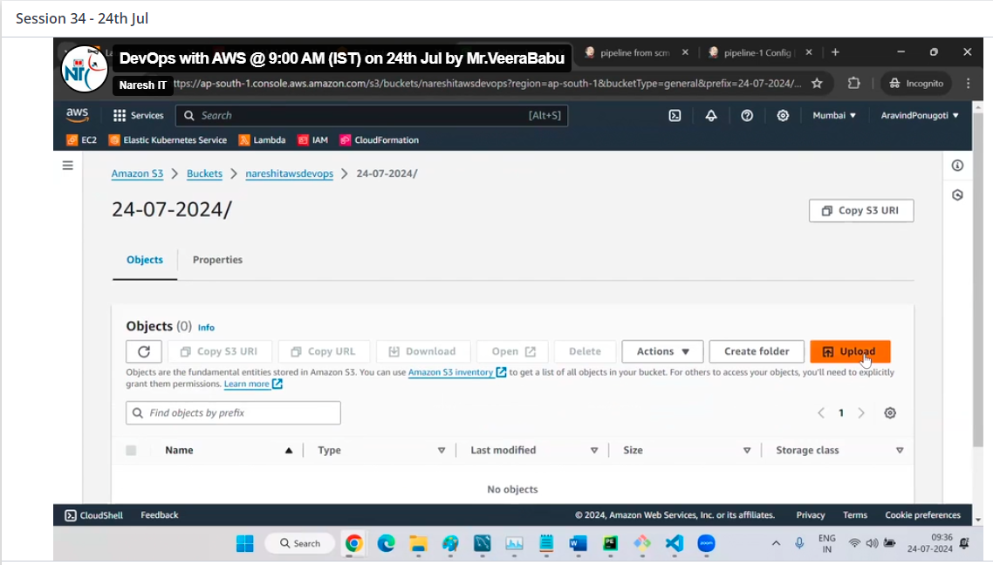

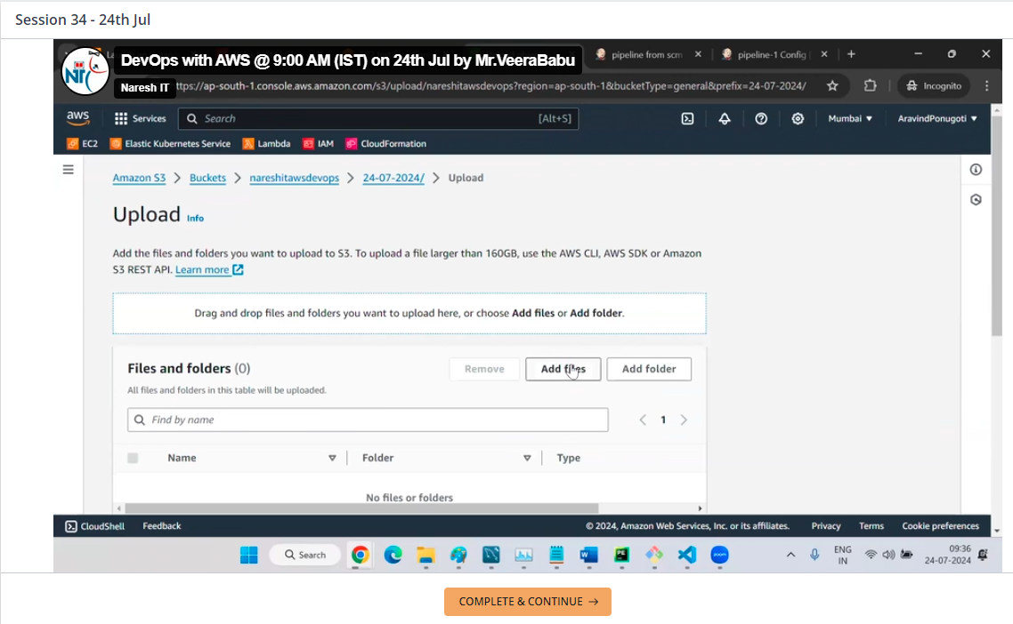

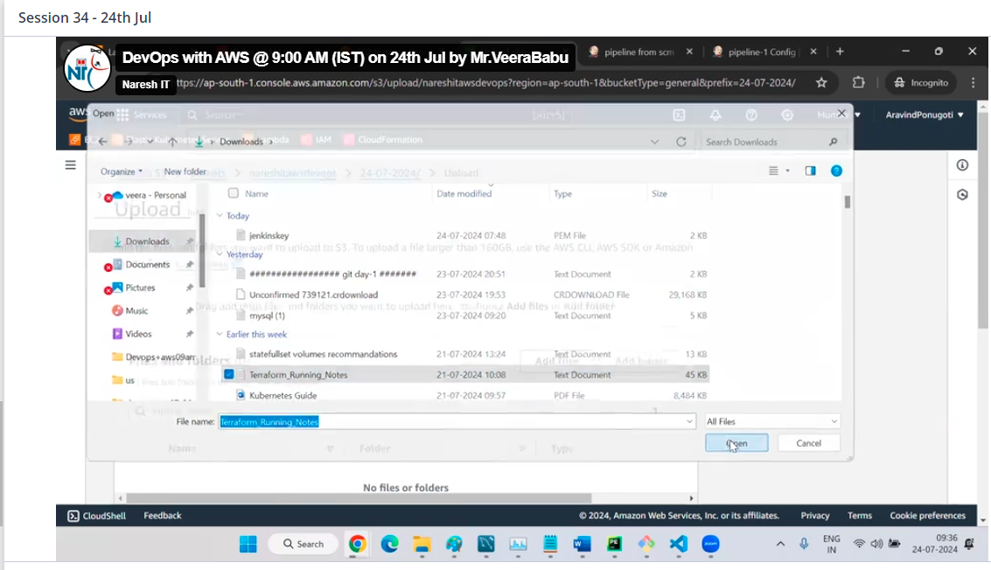

Then click on upload

We can share this file to public

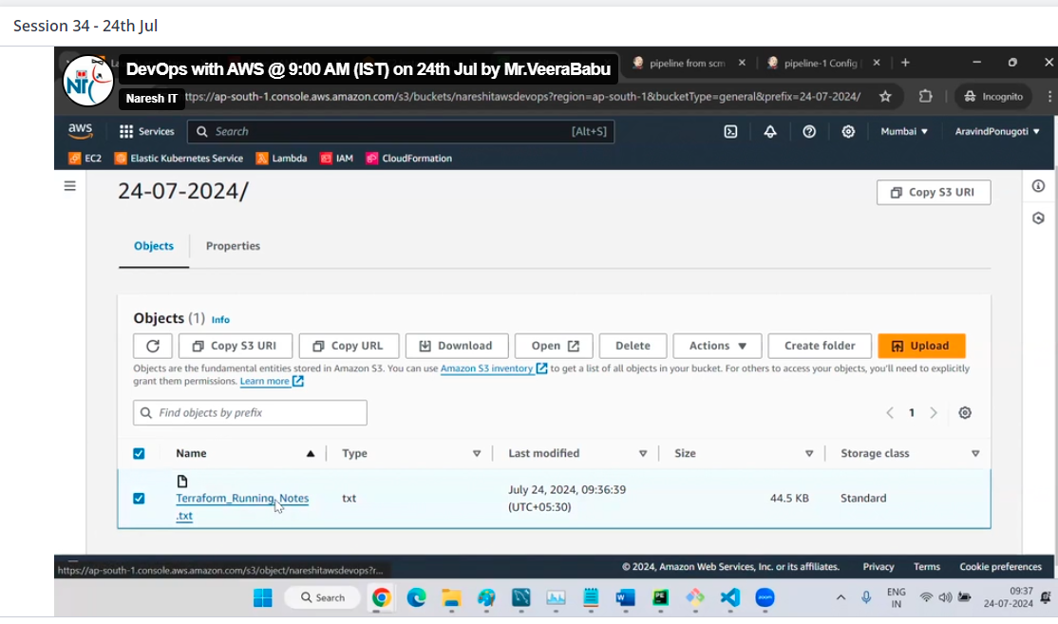

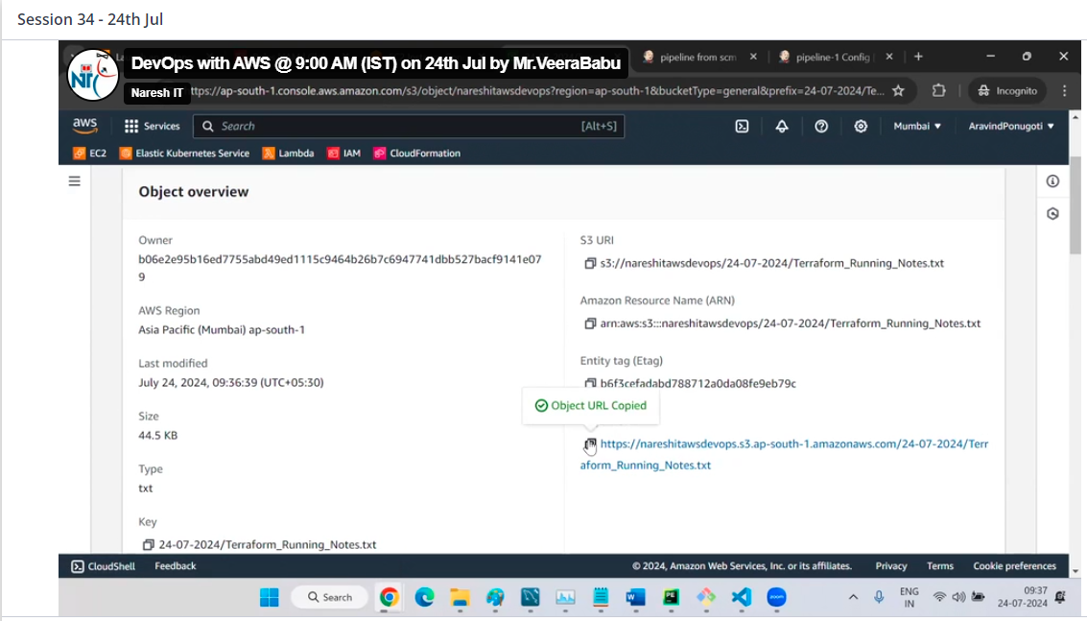

Share the object url to your friend

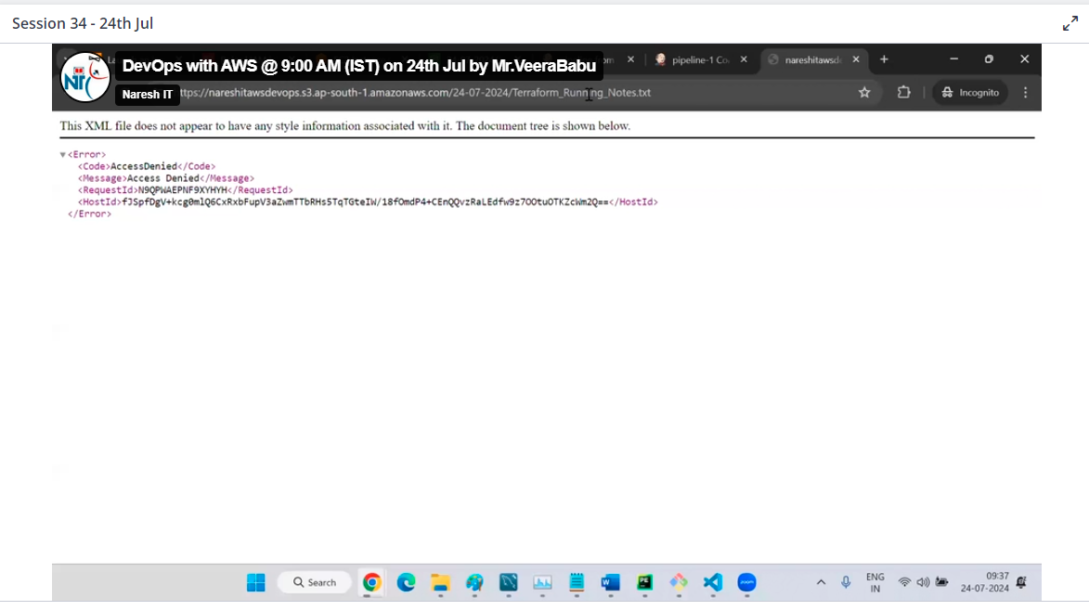

Here access denied event bucket public, so here we need to public the object too

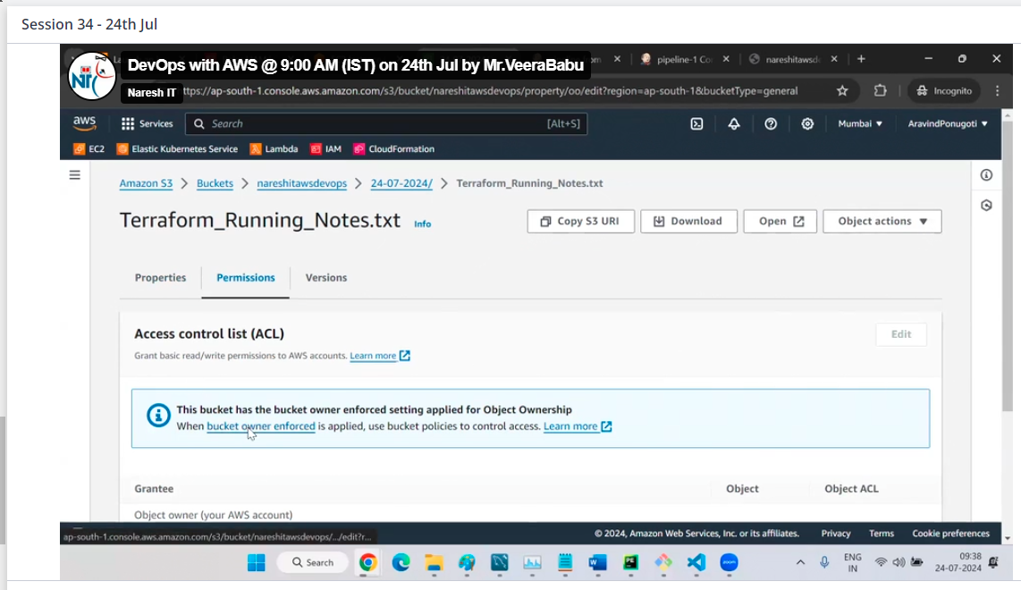

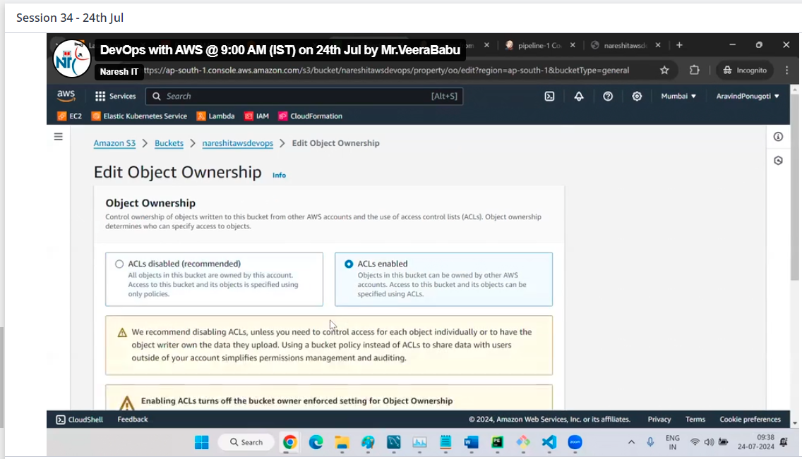

Then click on save changes

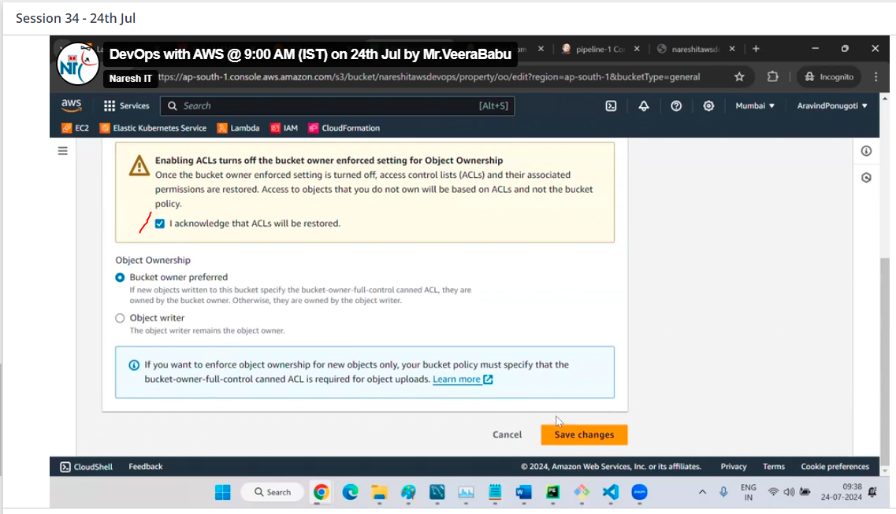

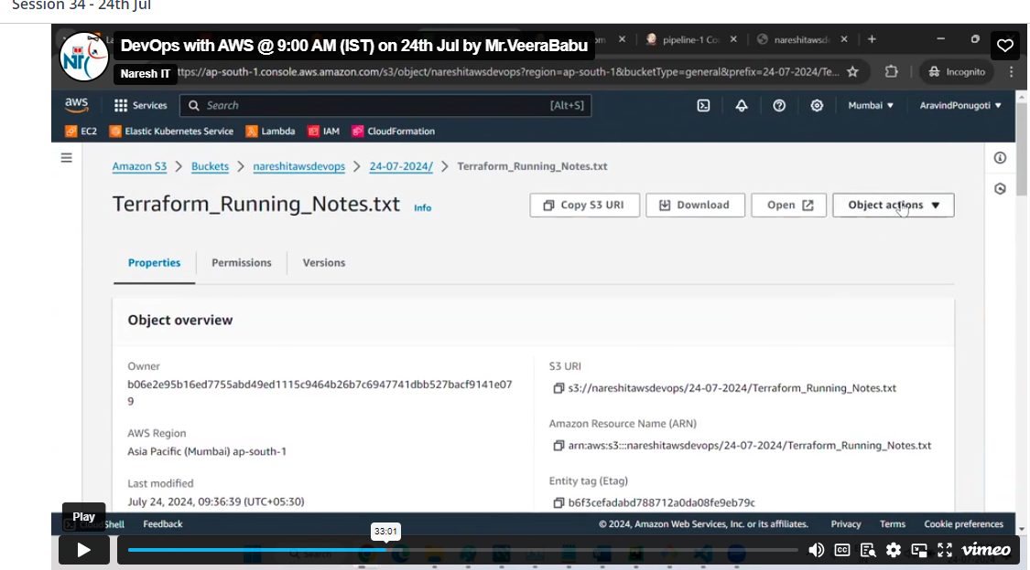

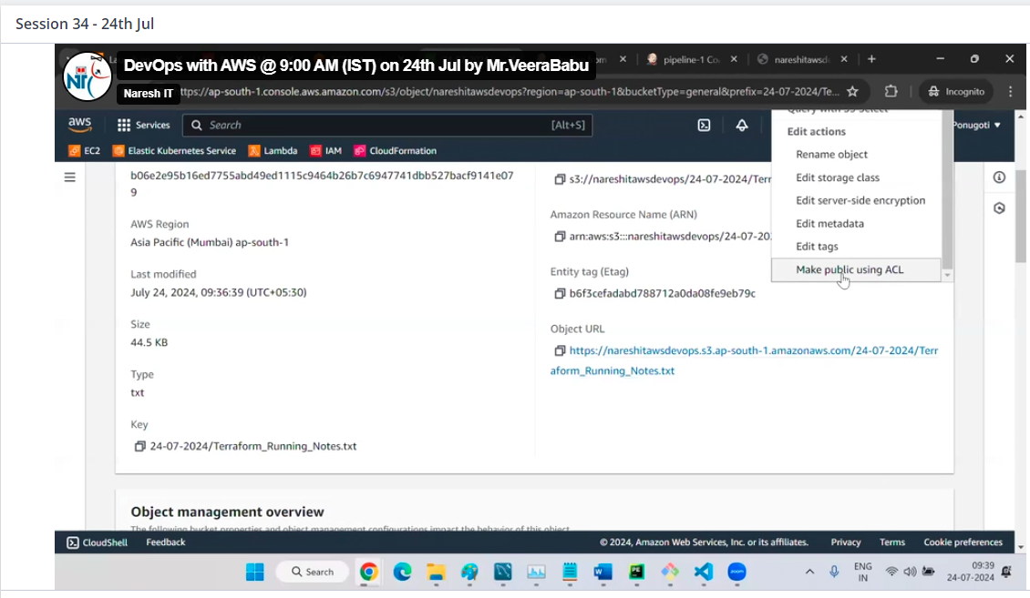

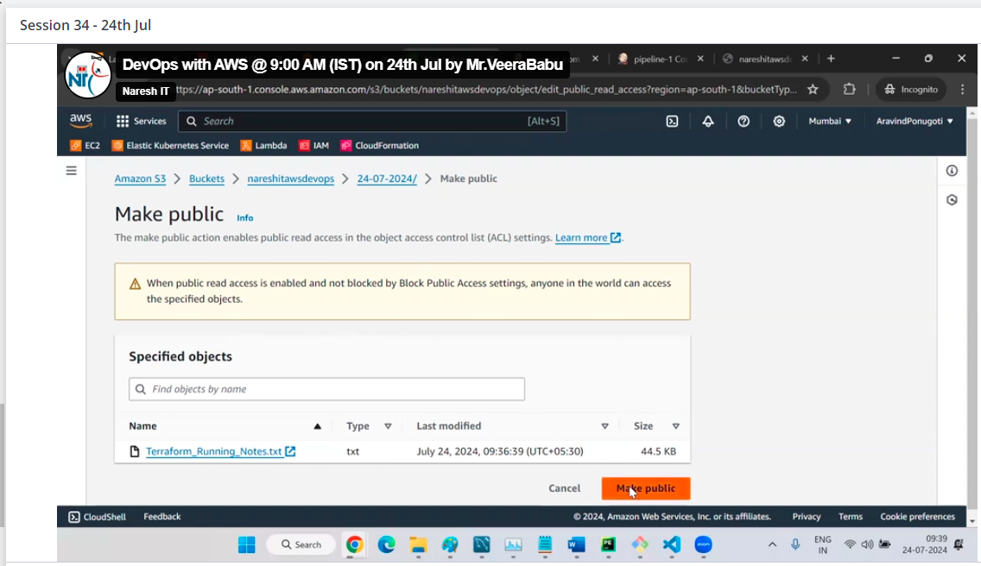

Then click on close

No click on url we can get access to

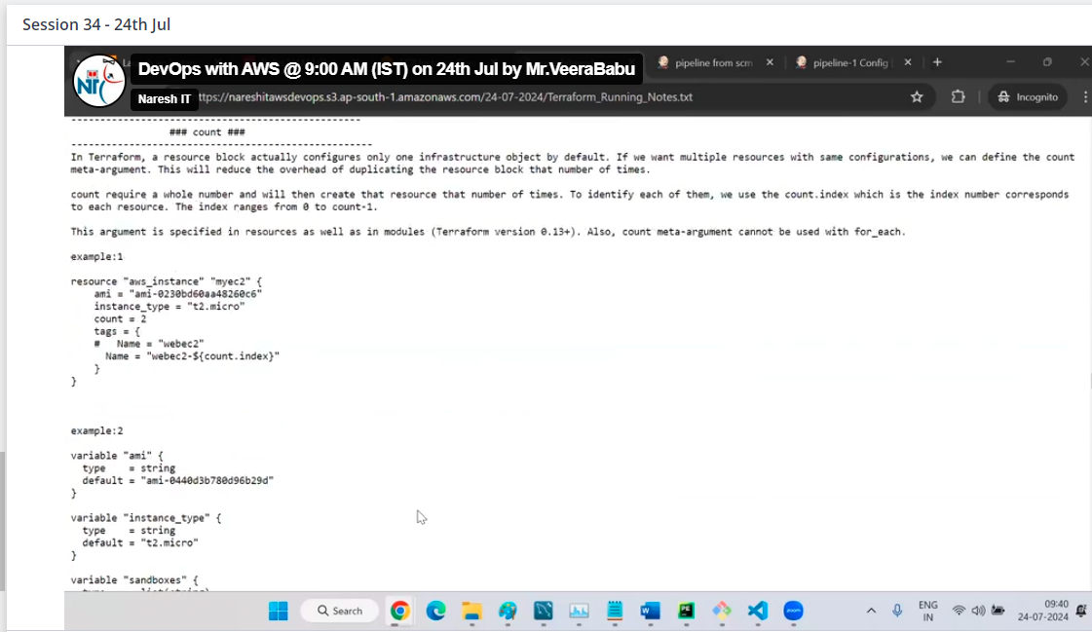

To enable the version of S3 bucket

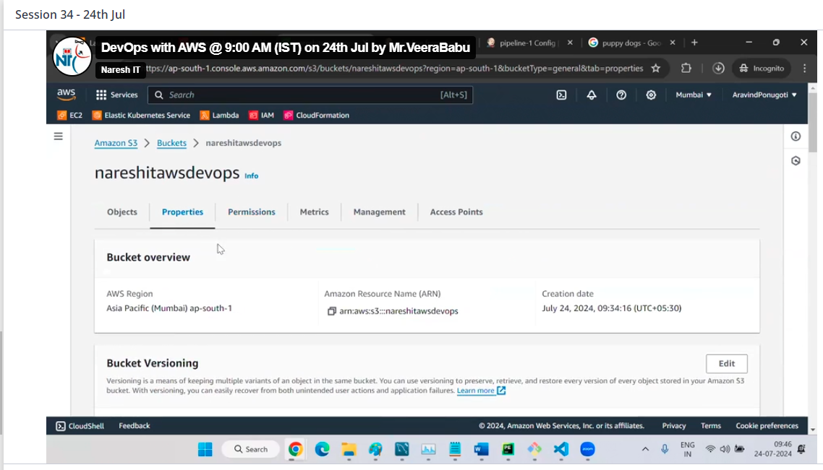

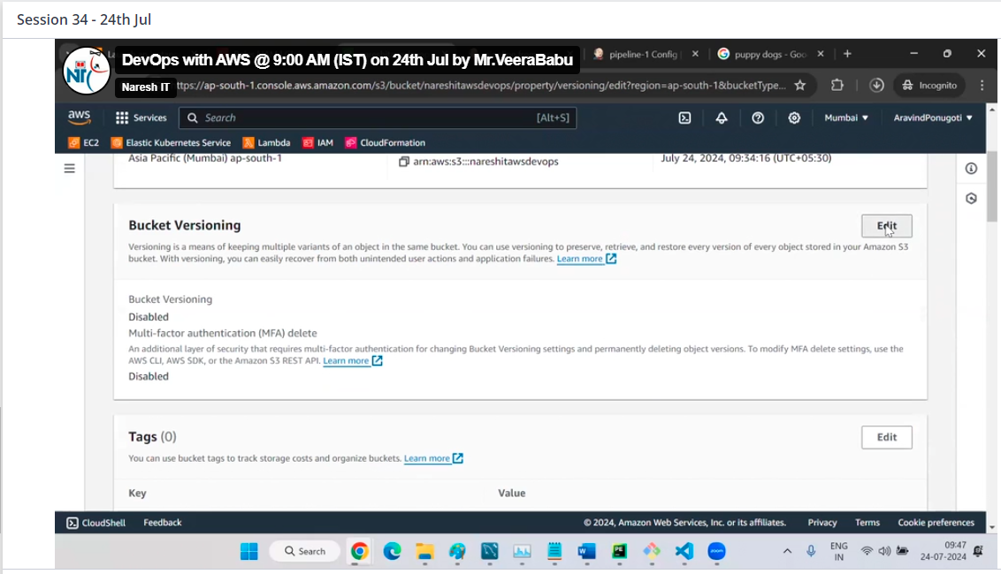

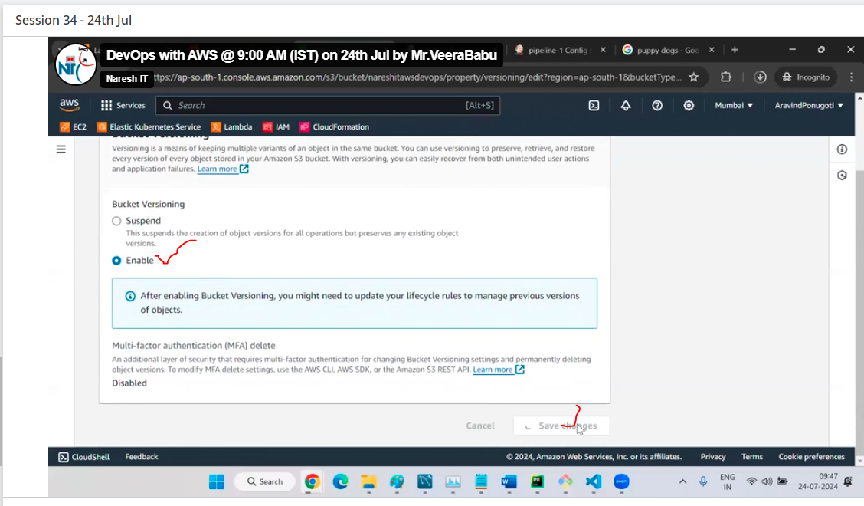

What is the use of bucket version

By using this we can take the back up of file and track the each record

See this now

Upload a file with hi1

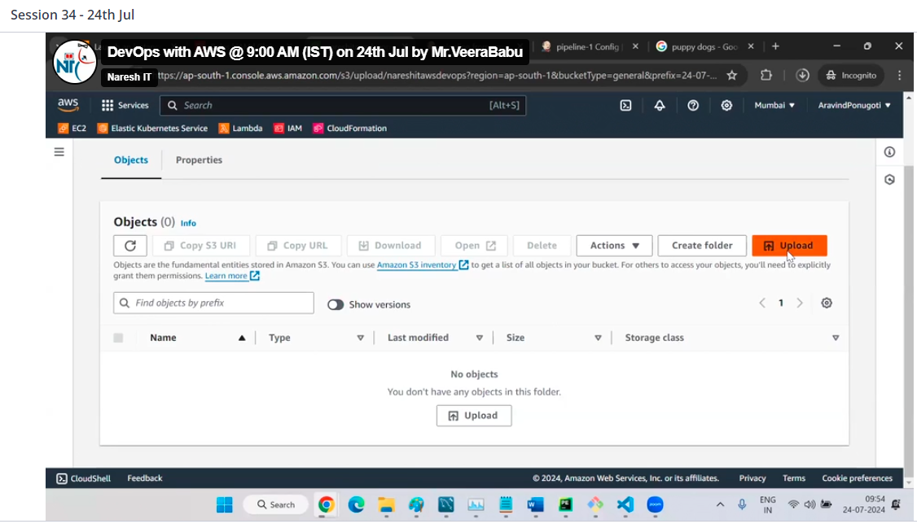

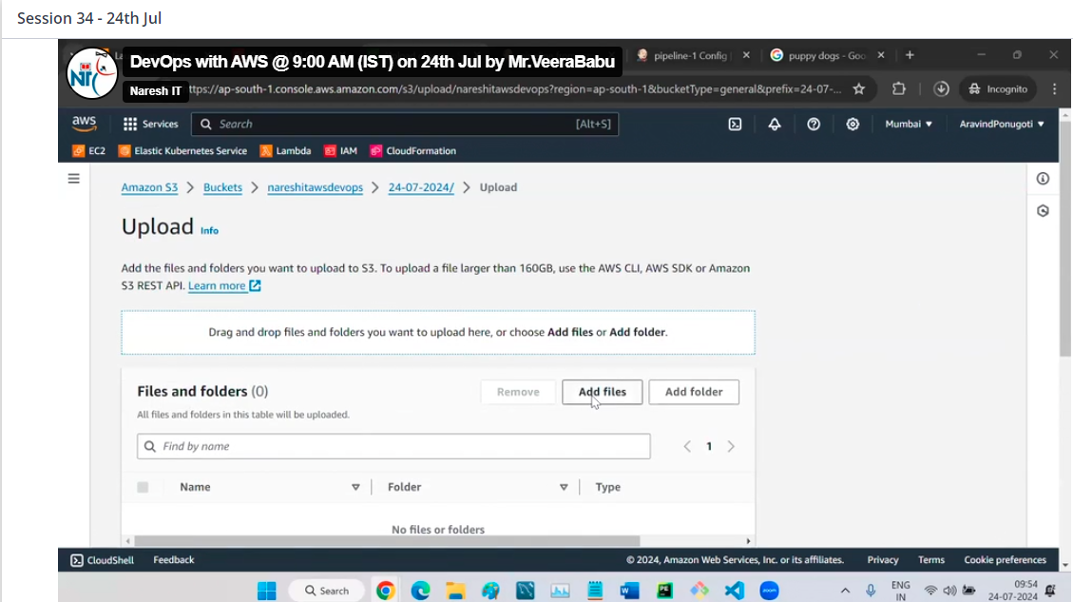

Click on upload

Now in local change the content as hi1 ,hi2 and save in local

And now upload the same file again into S3 bucket

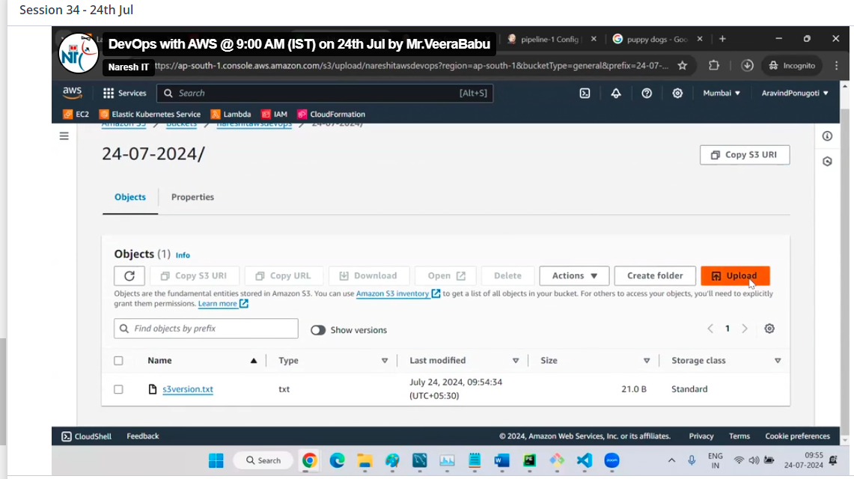

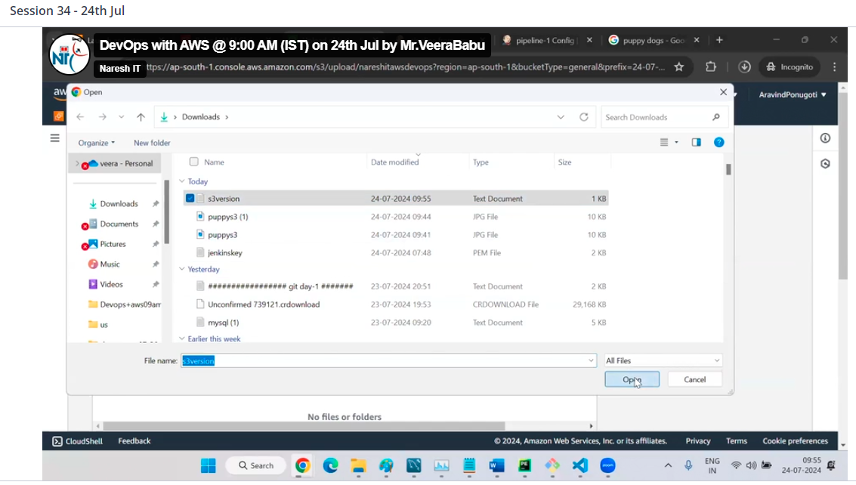

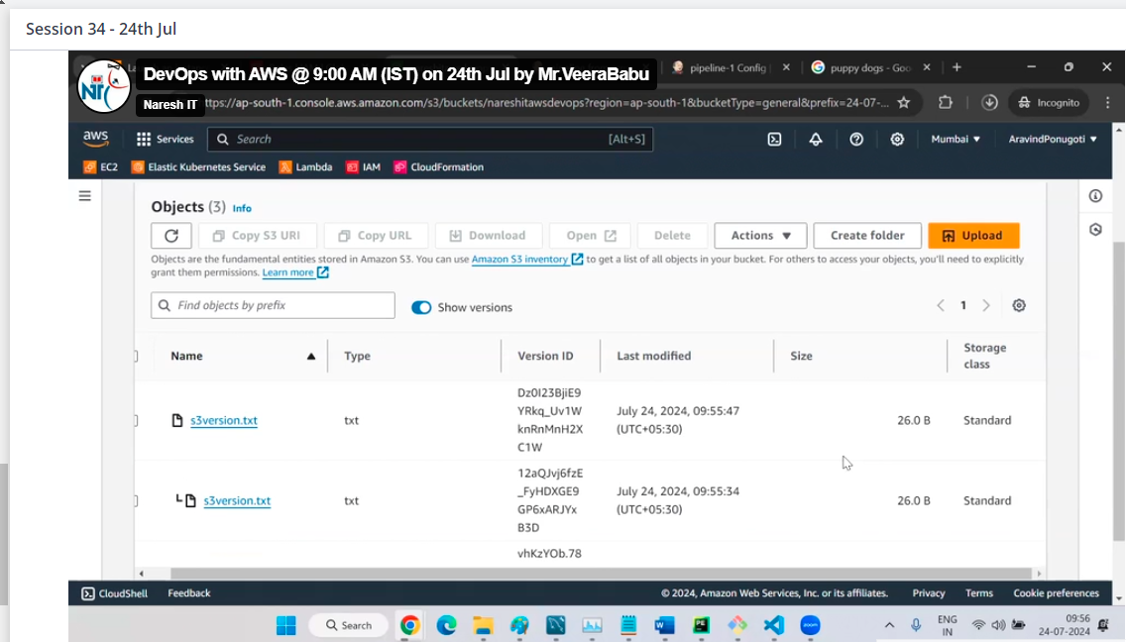

In local only one file, but in S3 bucket by click on versions we can see 2 file of different text with time too

And we can also download

S3 replication

2 buckets

2 regions

We have 1 bucket

Create a bucket in another region we can see here all buckets

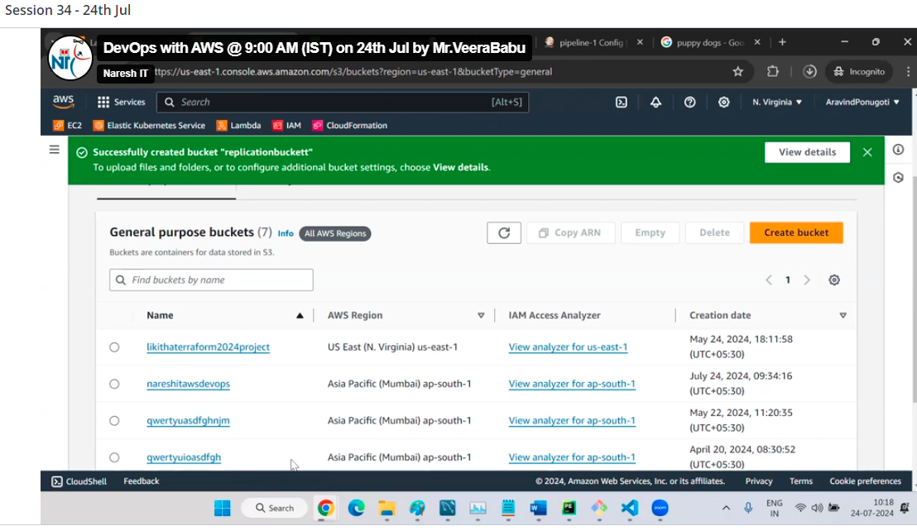

Go to source bucket

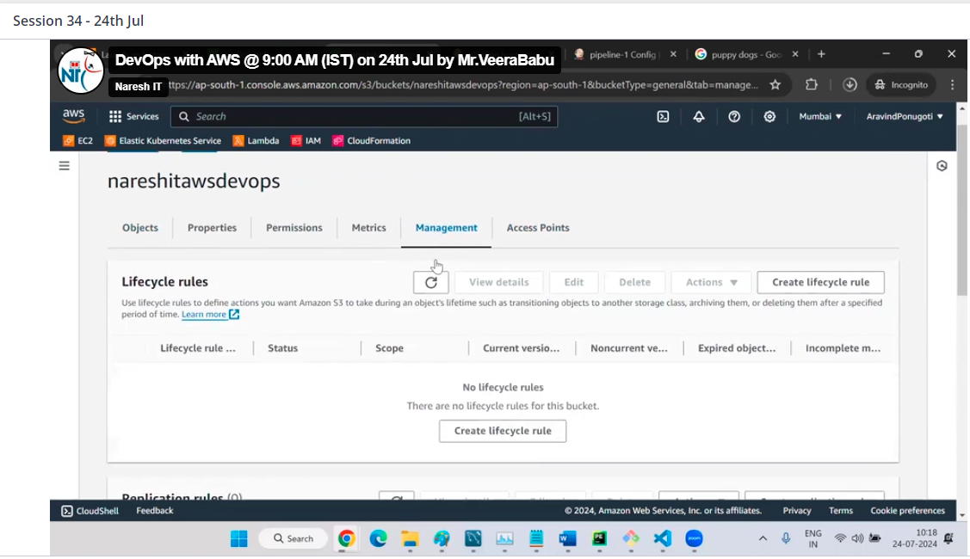

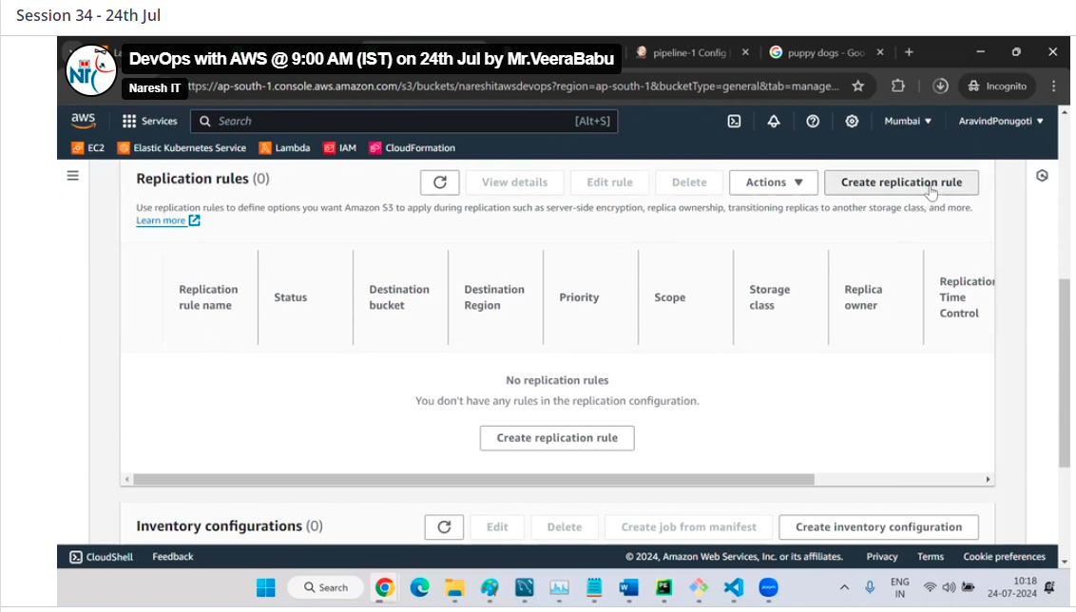

Any name here

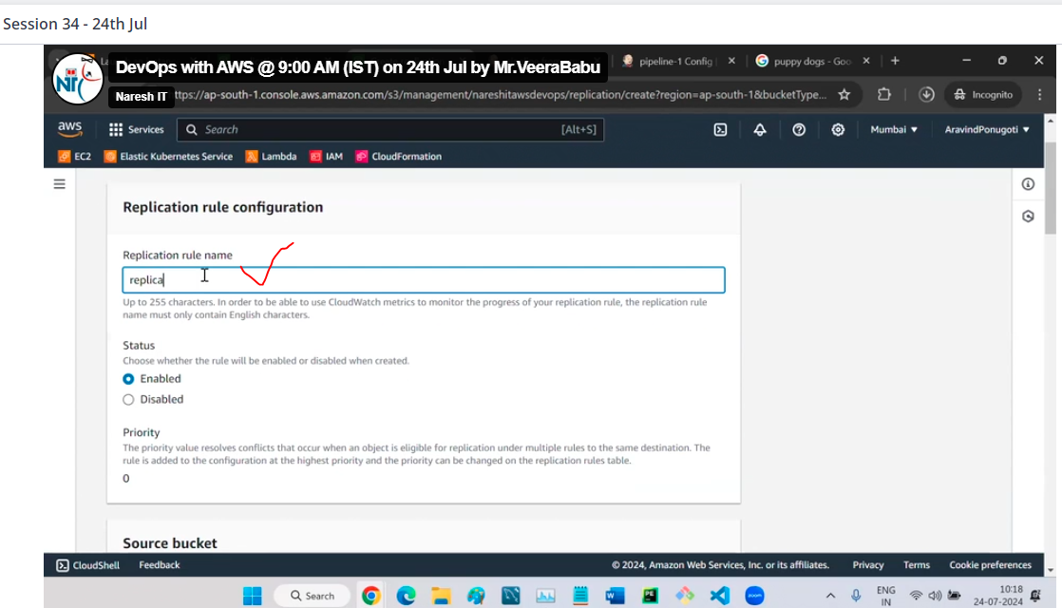

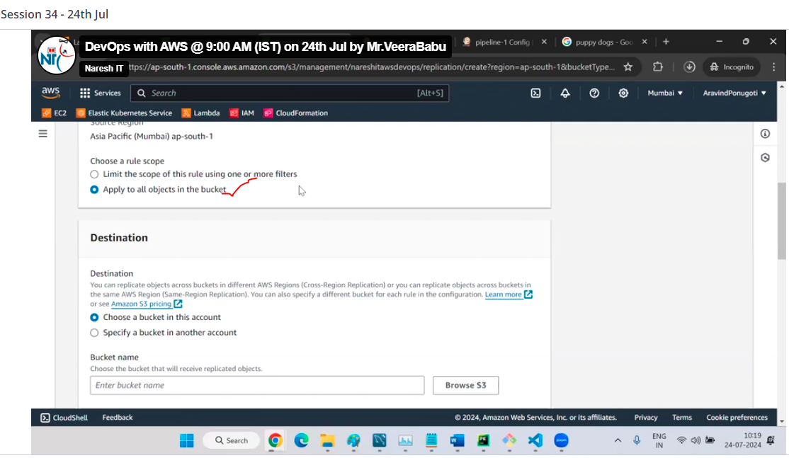

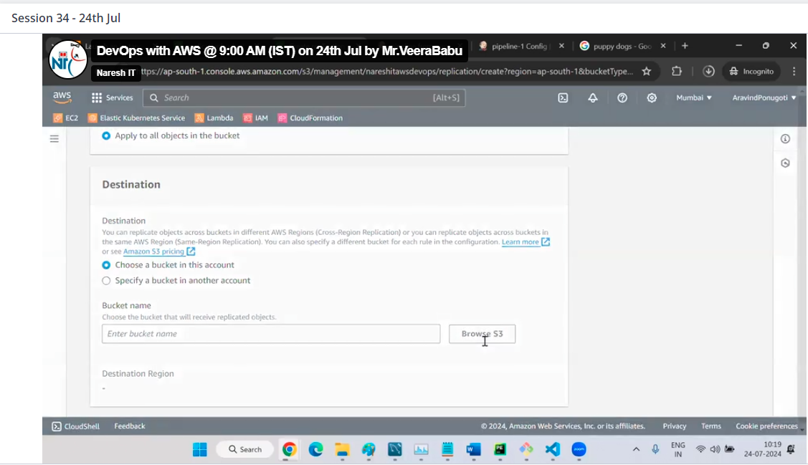

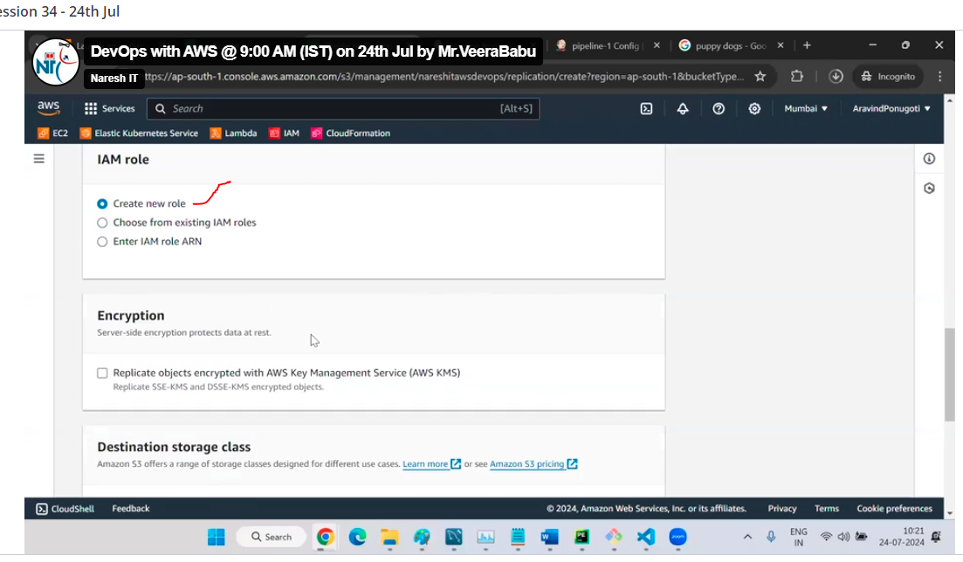

Click on save

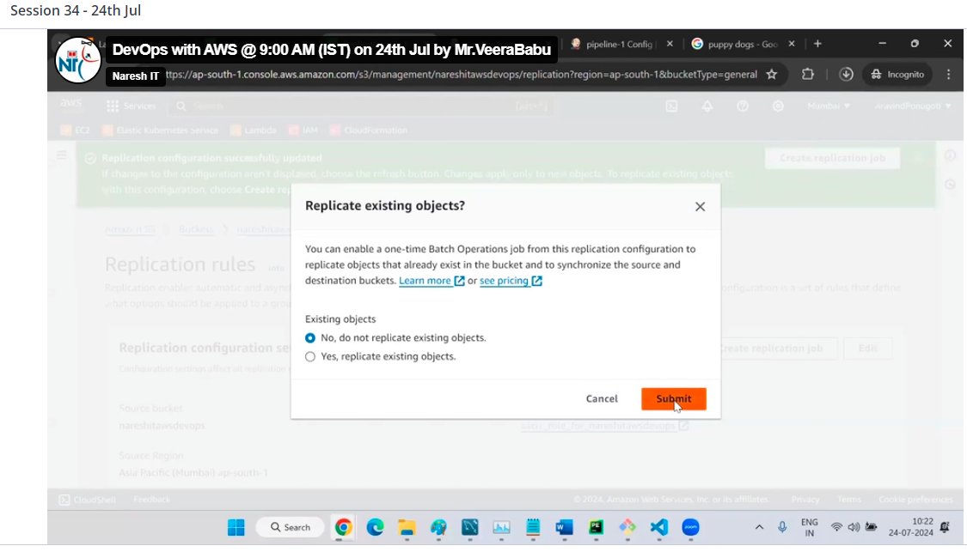

Now upload a file in source bucket

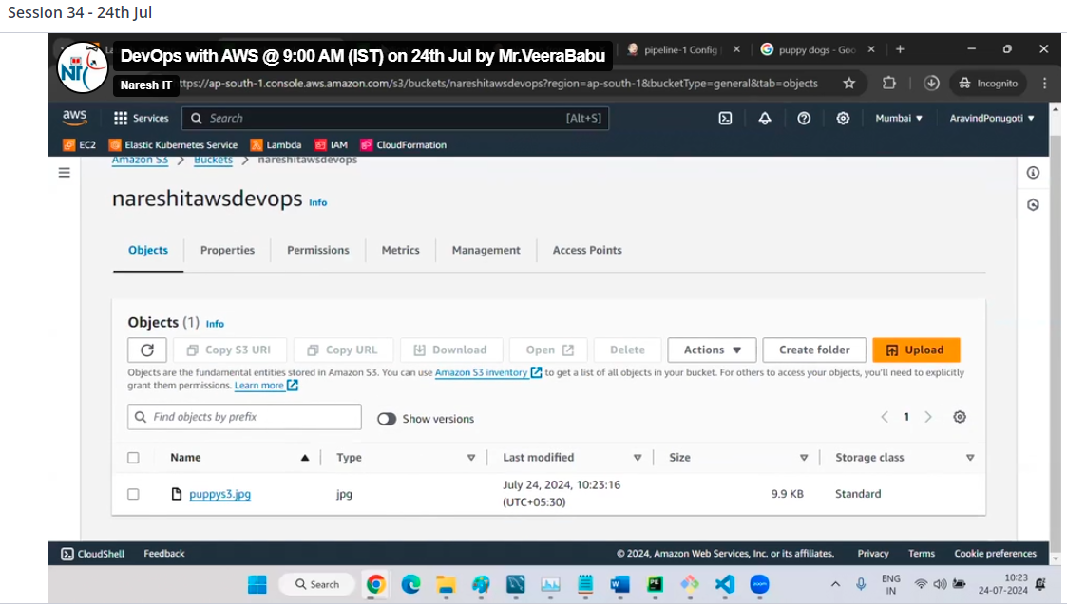

Now you can see the file automatically in destination bucket

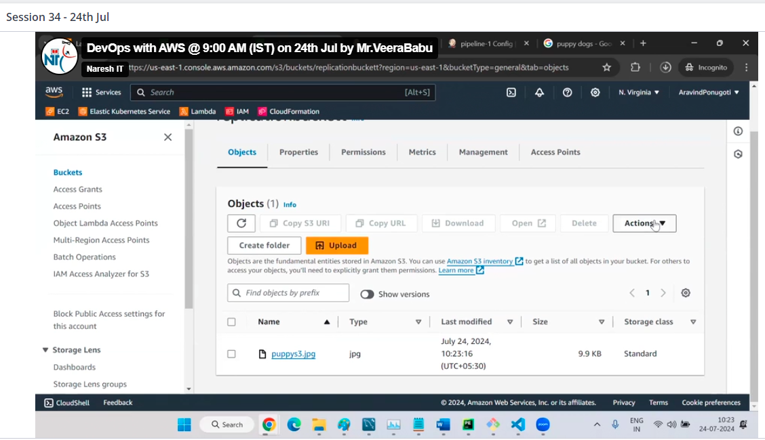

Now delete the object

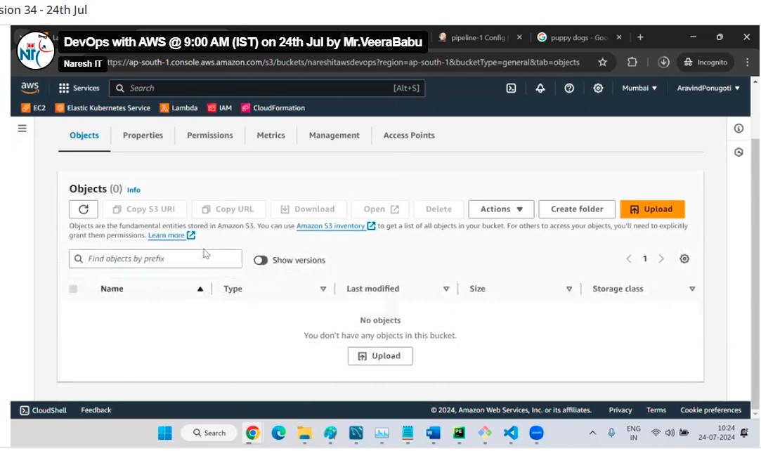

Even thought file is not deleted in destination bucket

